To All World Archery Europe Member Associations

Dear President,

on behalf of the Organizing Committee (OC), we would like to invite your country to the 2024 European Continental Qualifier Tournament, which will be held from May 4 - 7, 2024 Essen, Germany.

We are looking forward to welcoming you in Essen.

Sincerely yours,
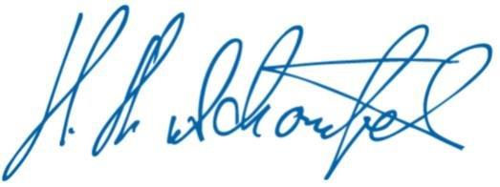

Hans-Heinrich von Schönfels
President of the
Organizing Committee

Important Dates:

Please find enclosed detailed information regarding this event. To register participation, please complete all the necessary sections in WAREOS (https://extranet.worldarchery.sport) within the deadlines listed below.

Summary of deadlines:
- Preliminary Entries 04/02/2024
- Preliminary Hotel Reservation 05/02/2024
- Final Hotel Reservation 05/03/2024
- 80% Deposit Hotel Payment 05/03/2024
- Final Rooming 01/04/2024
- Final Transportation 01/04/2024
- Final Entries 15/04/2024
- Visa Support 01/04/2024
- Remaining Payments (Entries/Transportation/Hotel) 01/04/2024
- Refund Cancellation Deadline* 05/02/2024
*After this deadline the LOC is allowed to retain all amounts due to the MA.

PRELIMINARY PROGRAMME:

04/05/2024  Saturday | Arrival of participants  Practice Field and Local Transportation  Official Training
05/05/2024  Sunday | Qualification Rounds  Eliminations
06/05/2024  Monday | Quarter Finals and Finals
07/05/2024  Tuesday | Departure

NOTE:
This preliminary program is subject to change according to the number of participants and special requirements. All changes will be published and distributed in good time.

PRELIMINARY & FINAL REGISTRATION
All entries, accommodation reservations, transport needs, flight arrival/departure information and visa invitation letter requests are to be completed using the World Archery Online Registration System WAREOS https://extranet.worldarchery.sport. This system handles the entire registration process for this event. No entry forms, hotel reservations or transportation forms will be accepted; all information must be entered into WAREOS.

Member Associations can login to WAREOS at https://extranet.worldarchery.sport with the username and password assigned by World Archery. After entering WAREOS, selecting the event from the list will allow a member association to register their athletes. Select/press the “Entries” button to see the list of categories in the event. Select/press the “category” to enter the athlete and official numbers/details participating for that event. A WAREOS User Manual can be downloaded in PDF format (English) upon login.

Contact wareos@archery.sport with any questions regarding technical problems on WAREOS. For any question regarding the organization of the event (transport, accommodation, meals, invoices, visa etc.) please contact directly the LOC.

A maximum number of three (3) athletes per country can be registered into each category and divisions of the event.

Any changes that are made after the deadlines specified or if entries differ by more than 4 athletes from the preliminary entries, the following penalty fees will automatically be applied:
Penalty fees to be paid to Organizing Committee: | Cost (EURO):
Entries made after the preliminary and/or final entry deadline date. | 50 per entry
If final entries differ from the preliminary entries by more than 4 athletes/officials. | 150 per entry
Failure to have made preliminary entries before the deadline date but then have submitted final entries. | 150 per entry

Any entries received less than 3 days before the team managers’ meeting will be refused if no preliminary entry and/or final entry are made prior.
As a final note, only Member Associations in good standing will be eligible to compete. This means that World Archery fee must have been paid prior the participation.
ACCOMMODATION & GENERAL INFORMATION
All room rates are calculated per room per night including full board (Breakfast, lunch and dinner). Lunch will be served at the competition venue.
All room rates include the current German VAT. Please note that in case of an increase, we must increase the room rates as well.

It is mandatory to choose the official hotel listed by the Local Organizing Committee. A delegation choosing a non-official hotel will not be allowed to participate in the Championships.

Hotel Essener Hof****
https://www.essener-hof.com

EUR 187 / single incl. full board
EUR 316 / double incl. full board
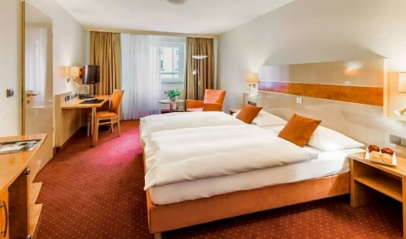
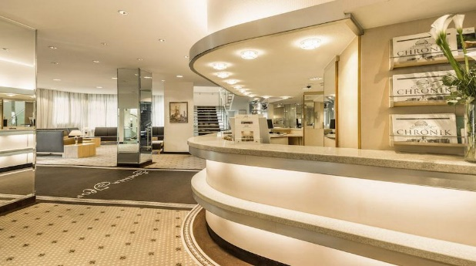
This 4* hotel is situated in the city centre of Essen. The hotel offers 114 rooms and it’s close to attractions, shops, restaurants, and public transportation. Hotel Essener Hof generally provides a range of amenities to make guests' stays enjoyable. This includes a restaurant serving breakfast and dinner, a bar, a fitness center, complimentary Wi-Fi access. Due to its central location in Essen, many of the city's key attractions and sights are easily accessible.

Intercity Hotel Essen****
https://hrewards.com/de/intercityhotel-essen

EUR 193 / single incl. full board
EUR 310 / double incl. full board
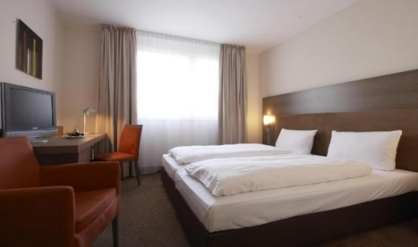
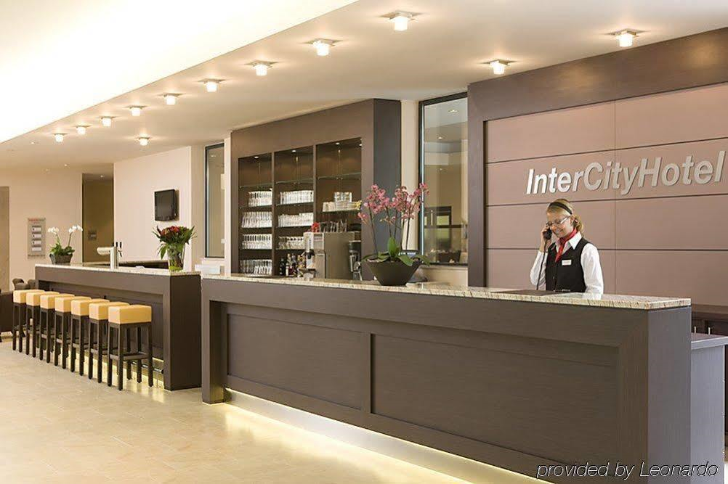
The 4* Hotel Essen is centrally located in the city of Essen. The hotel offers 167 comfortable and modernly furnished rooms. It is situated near Essen's main train station, providing excellent access to public transportation and making it convenient for guests to explore the city's attractions and shops in the downtown area. Rooms typically come equipped with amenities such as a flat-screen TV, a desk, complimentary Wi-Fi. There is a parking garage directly at the hotel.

Ramada Hotel Essen****
https://www.wyndhamhotels.com/de-de/ramada/essen-germany/ramada-essen/overview

EUR 183 / single incl. full board
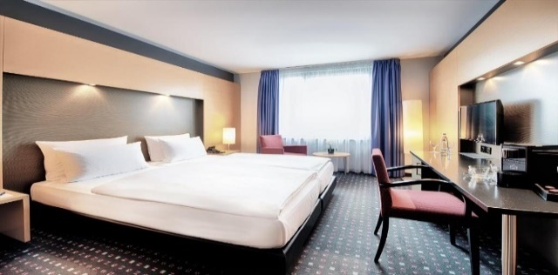
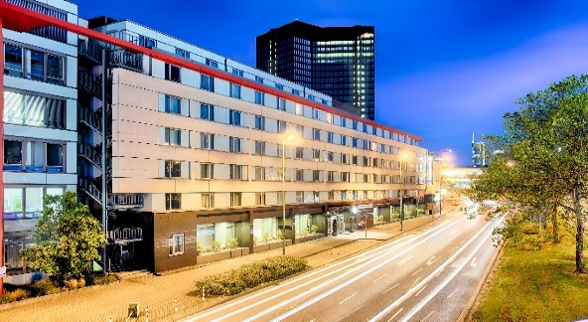
EUR 306 / double incl. full board

The 4* Ramada Hotel in Essen is conveniently situated near the city center of Essen. The hotel offers 176 rooms. This location provides guests with easy access to key attractions, shops and restaurants. The soundproofed rooms and suites of the Ramada by Wyndham Essen all feature satellite TV, extra-long beds and a work desk. The bathrooms provide a hairdryer and shower products. Wi-Fi access is available for free. Decorated in warm, red tones, the SunnySide à la carte restaurant with terrace serves seasonal cuisine. The Ramada by Wyndham Essen’s LoungeBar RedCorner offers a wide range of drinks. Hotel garage is nearby.

The niu Cobbles
https://the.niu.de/hotels/deutschland/essen/the-niu-cobbles

EUR 199 / single incl. full board
EUR 320 / double incl. full board
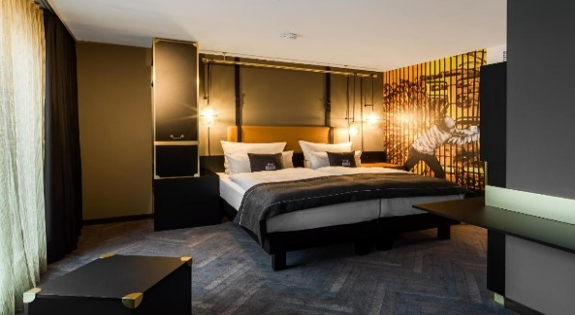
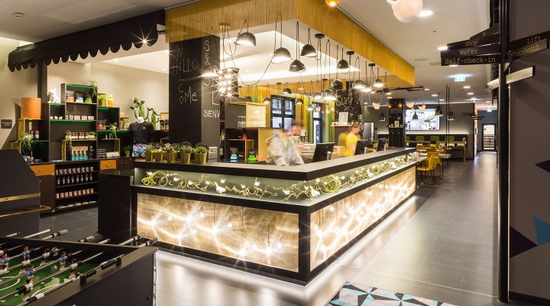

The niu Cobbles is a stylish and contemporary hotel situated in the vibrant city of Essen. It offers 146 rooms with its unique design and modern comfort. The hotel's exterior exudes an inviting and trendy atmosphere, featuring a blend of industrial and urban design elements that set it apart from traditional hotels. Additionally, the hotel provides convenient amenities such as free Wi-Fi and a fitness center. Its central location in Essen also makes it an excellent base for exploring the city's attractions. The niu Cobbles offers on-site parking that you can rent on a daily basis.

NH Hotel Essen****
https://www.nh-hotels.com/en/hotel/nh-essen

EUR 210 / single incl. full board
EUR 320 / double incl. full board
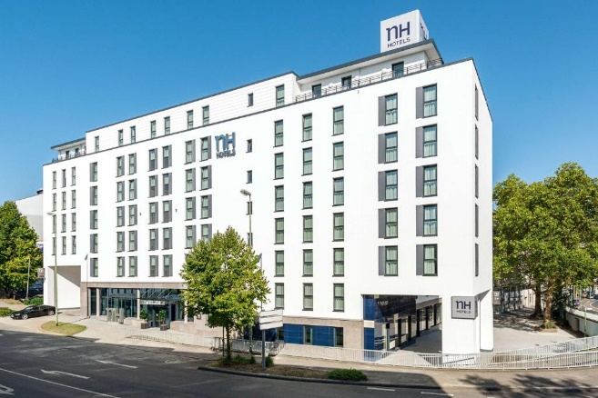
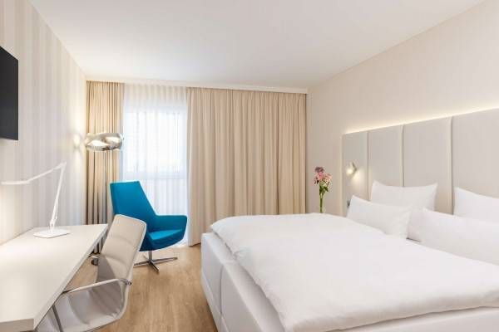

The 4*superior NH Hotel in Essen is a modern and stylish hotel located in the heart of Essen with popular attractions such as the Essen Cathedral, Zeche Zollverein (a UNESCO World Heritage Site) and the city's vibrant shopping and dining districts nearby. Additionally, excellent public transportation links make it easy to explore the wider region. The hotel offers 182 comfortable and elegantly designed rooms and suites. Each room is tastefully furnished with modern amenities, including flat-screen TVs, minibar and free Wi-Fi, to make your stay enjoyable and convenient. On-site parking around.

Webers Hotel Essen***
https://www.pottmomente.de/

EUR 203 / single incl. full board
EUR 332 / double incl. full board
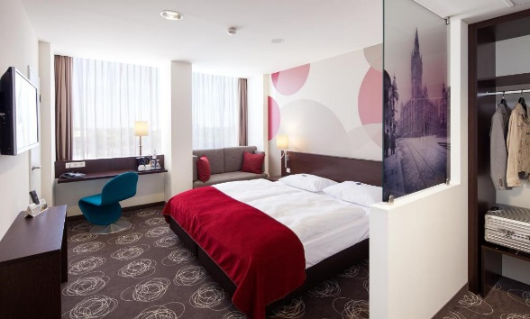
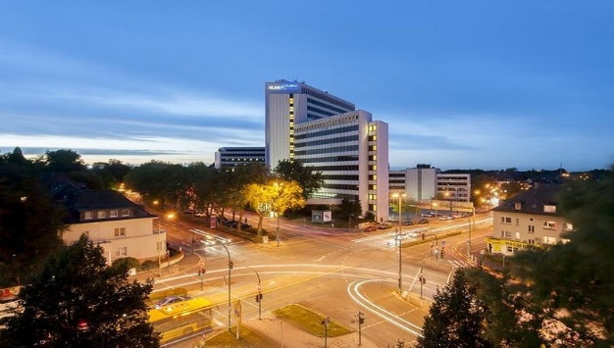
This 3* superior Hotel in Essen is located in the southern district of Essen, just 2 km from the city center. It offers 137 convenient furnished rooms featuring cable tv, coffee and tea maker and free Wi-Fi. Also included is a fitness center nearby the hotel. You can relax with a drink in the bar/lounge. There is a parking garage directly at the hotel.

PAYMENT CONDITIONS HOTELS:

To confirm hotel reservations, an 80% deposit of the total amount is required to be transferred to the HK Travel Plus GmbH before 05 March 2024 via a bank transfer using the details below. The remaining payment for accommodation should be paid by 01 April 2024.

Accommodation cannot be guaranteed after this deadline. In case of cancellation after 05 March and/or a no-show, the travel agency will charge a cancellation fee of 100% of the costs for all nights and rooms you have booked.

BANK INFORMATION FOR ACCOMMODATION ONLY

Account holder:
HK Travel Plus GmbH
Frauenlobstraße 97
D-55118 Mainz

Account:
Volksbank Alzey-Worms eG
Marktplatz 19
D-67547 Worms, Germany

IBAN DE 15 5509 1200 0080 518307
BIC GENODE61AZY

PLEASE DO NOT MAKE HOTEL PAYMENTS TO THE ORGANIZING COMMITTEE

Contact to Travel Agency
hk travel plus GmbH Phone: +49-6131-217098-0
Mrs. Birgit Huhn Fax: +49-6131-217098-20
Frauenlobstraße 97 E-mail: birgit.huhn@hktravelplus.de 55118 Mainz, Germany Web: www.hktravelplus.de

Venue
The Qualification and finals will be held at the Sportpark am Hallo.
Adress: Hallostraße 50, 45141 Essen
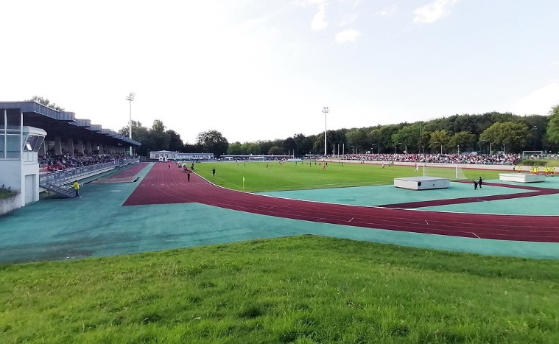

ENTRY FEE
Entry fee:
Individual: 200,00€ EUR per athlete
Officials: 125,00€ EUR per person
Guest: 100,00€ EUR per person

Entry fees include daily local transport to/from the practice field to/from the official hotels during the qualification, elimination and finals venues (timetable to be confirmed on site).
Entry fee for guest includes daily local transport between field to/from official hotels during the qualification, elimination and finals venues. They have no field of play access.

Airport Transportation Fee:
Roundtrip 90 Euro per person

Airport Transfer will be provided to/from the official hotels from two airports:
- Cologne/Bonn Airport (CGN)
- Dusseldorf Airport (DUS)

PAYMENT CONDITIONS:
The entry fees and Transportation fees should be paid fully via bank transfer or upon arrival.

NOTE:
- Please indicate in the reference/notes section the team or reservation name that corresponds to the payment.
- All payment shall be made in EURO by BANK TRANSFER.
- All bank wire charges will be paid by the participant
- CREDIT CARDS will not be accepted as payment.

Payment of Entry and Transportation Fees

All Entry Fee and transportation fees must be made to the Organizing Committee by the set deadline. The payment for the entry fee and transportation fee must be transferred to the following bank account:

German Shooting Sport and Archery Federation/Deutscher Schützenbund e.V.
Lahnstr. 120, 65195 Wiesbaden, Germany

Account:
Wiesbadener Volksbank
Schillerplatz 4
65185 Wiesbaden, Germany
IBAN DE16 5109 0000 0008 8088 80
BIC WIBADE5W

ADDITIONAL INFORMATION
There is a separate Invitation Package for the European Outdoor Championships as well as the World Archery Europe Congress.

Training
A training field will be available starting on 04 May 2024. Transport to training field will be made available at no additional cost.

Weather
Temperatures in May are expected to range between 12 and 20 degrees Celsius. The average in the last few years has been 18 degrees Celsius.

Media Registration:
Media representatives can apply for registration by emailing info@archery.sport

Internet
Will be available in the official hotel for free (in hotel rooms and in the lobby). There will also be Wi-Fi available at the venue.

Water
Bottled water or drinking water stations will be available at the venue.

LOC Contact:
Name: Ms. Julia Matheis, Event Manager
Email: matheis@dsb.de
Phone: +49 611 46807 415
Language: English, German

Visa:
It is your responsibility to establish with your respective foreign office if your team requires a visa for Germany. You can find additional information on https://www.auswaertiges-amt.de/en/visa-service. All participants who need an entry visa to Germany, will be required to complete the Visa Support Form in WAREOS by no later than 01 April 2024.

It is the applicants’ responsibility for supplying the necessary information, ensuring all details are up to date, correct and submitted by the deadlines specified.

In addition, all participants that require a visa are kindly requested to supply a copy of their latest/valid passport. Copies of each application can be uploaded on WAREOS. All passport copies and personal details entered/uploaded to WAREOS will be held securely and in the strictest of confidence and not shared with other parties.

Please ensure your passport is valid for at least six months from the date you enter Germany, or you may not be admitted.

