TO ALL World Archery Europe Member Associations

Dear President,

As the chairman of the local organizing committee (LOC) of the European Archery Field Championships 2025, Książ/Wałbrzych – Poland, we would like to invite your country to this event, which will take place from 15 to 20 September in Książ – Poland. Welcome to this amazing city that is reborn every day. Our targets are eagerly waiting to receive your arrows, just as our hearts are ready to make your visit an unforgettable experience. Please find attached the necessary information regarding registration, organization and participation in this event. We look forward to welcoming you and your team to the vibrant and historic city of Książ – Poland. Best regards,

**JÓZEF BAŚCIUK**

**Książ 2025 European Field Championships OC Chairman**

**IMPORTANT DATES:**

Please find enclosed information regarding the details of this event and how to complete registration. To register participation, please complete all the necessary sections in WAREOS within the deadlines listed below:

Summary of deadlines:

Registration Opening date - WAREOS 15 April 2025

Visa Support Deadline 9 May 2025

**Preliminary Entries Deadline** **17 June 2025**

Preliminary Hotel Reservation 17 June 2025

Hotel Reservation & 50% Payment 17 June 2025

**Final Entries Deadline** **26 August 2025**

Entry Fee Payment Deadline 26 August 2025

Final Hotel Reservation & Full Payment 26 August 2025

Transportation & Full Payment 26 August 2025

Looking forward to welcoming you in Książ-Wałbrzych, Poland.

**VENUE LOCATION**

|  |  |
| --- | --- |
| Practice venue | Książ-Wałbrzych |
| Qualifications venue | Książ-Wałbrzych |
| Finals venue | Książ-Wałbrzych |

**PRELIMINARY PROGRAMME**

|  |  |  |
| --- | --- | --- |
| Day -2 | Saturday  13 September | Arrival of Delegations  Unofficial Practice field and local transportation available  Team Registration |
| Day -1 | Sunday  14 September | Arrival of Delegations  Unofficial Practice field and local transportation available  Team Registration |
| Day 0 | Monday  15 September | Official Practice and equipment inspection  Team Managers' Meeting  Opening Ceremony |
| Day 1 | Tuesday  16 September | 1st Qualification Round – 24 targets unmarked |
| Day 2 | Wednesday  17 September | 2nd Qualification Round – 24 targets marked  Mixed Team Eliminations |
| Day 3 | Thursday  18 September | Individual Eliminations |
| Day 4 | Friday  19 September | Team Eliminations  Team and Mixed Team Bronze Medal matches  Team & Mixed Team Gold Finals |
| Day 5 | Saturday  20 September | Semifinals  Individual Finals  Award & Closing Ceremony |
| Day 6 | Sunday  21 September | Departure of Delegations |

**NOTE**: This preliminary program is subject to change according to participation and TV requirements. All changes will be published and distributed in good time.

**PRELIMINARY & FINAL REGISTRATION**

All entries, accommodation reservations, transport needs, flight arrival/departure information and visa invitation letter requests are to be completed using WAREOS.

The World Archery Online Registration System (WAREOS) at [https://extranet.worldarchery.sport](https://extranet.worldarchery.sport/) handles the entire registration process for this event. No entry forms, hotel reservations or transportation forms will be accepted; all information must be entered into WAREOS.

Member associations can login to WAREOS at [https://extranet.worldarchery.sport](https://extranet.worldarchery.sport/) with the username and password assigned by World Archery. After entering WAREOS, selecting the event from the list will allow a member association to register their athletes. Select/press the “Entries” button to see the list of categories in the event. Select/press the “category” to enter the athlete and official numbers/details participating for that event. A WAREOS User Manual can be downloaded in PDF format (English) upon login.

Contact [wareos@archery.sport](mailto:wareos@archery.sport) with any questions regarding **technical problems on WAREOS**. For any question regarding the organisation of the event (transport, accommodation, meals, invoices, visa etc.) please contact **directly the LOC**.

A maximum number of 3 athletes per country can be registered into each category of the event. Preliminary entries should be completed using WAREOS.

Member Associations can only use WAREOS to make any changes, amendments or cancellations to entries and will be able to do so at any time. An email will automatically notify the Organising Committee and Member Association of any changes made in WAREOS.

**ENTRY FEE**

|  |  |
| --- | --- |
| **Entry Fees:** |  |
| Individual: | **250 EUR** per athlete |
| Officials: | **125 EUR** per person |
| Teams: | **150 EUR** per team |
| Mixed Team | **no entry fee** |

Start date for online registration using WAREOS: **15 April 2025**

End of Preliminary registration using WAREOS: **17 June 2025**

End of Final registration using WAREOS: **26 August 2025**

Please respect the stated deadlines.

Any changes that are made after the deadlines specified or if entries differ by more than 4 athletes from the preliminary entries, the following penalty fees will automatically be applied.

Any entries received after the final registration deadline will be refused. Only substitution will be allowed.

Entries and substitutions received after the deadlines are subject to penalties as clearly stated herein. A Member Association that has made final entries in WAREOS and does not participate will be invoiced for the number of entries entered in the system as well as any other booking they made through the platform (including but not limited to accommodation, transportation, and any other extras the Member Association has booked through the platform).

|  |  |
| --- | --- |
| **Penalty fees to be paid to Organising Committee:** | **Cost (EUR):** |
| Entries made after the entry deadline dates (late entries) | **50** per entry |
| If final entries differ from the preliminary entries by more than **4** athletes/officials. | **150** per entry |
| When no preliminary entries were made before the deadline date but then submit final entries. | **150** per entry |

**NOTE:**

Member Associations that have penalty fees outstanding from earlier events will need to pay these penalty fees and get good standing before being eligible to enter and compete.

Also, World Archery fee must have been paid prior the participation.

**ACCOMMODATION**

***Important Note***

***Non-official accommodation is not allowed. Any team or individual accommodated in non-official hotel will not be accredited and participation in the event will be refused.***

Hotels are especially selected by the organization for the event.

* Reservations should be made before **17 June 2025**
* Final Hotel Reservation & Transportation before **26 August 2025**

**Zamkowy Hotel – three Star Hotel**

* Single Room price: EUR 180.00 per room
* Number of rooms: 7
* Double/Twin Room price: EUR 280.00 per room
* Number of rooms: 8
* Triple Room price: EUR 330.00 per room
* Number of rooms: 6
* Board plan: breakfast and dinner
* Check-in from 13 September 2025
* Hotel website: <https://zamekksiaz.pl/>

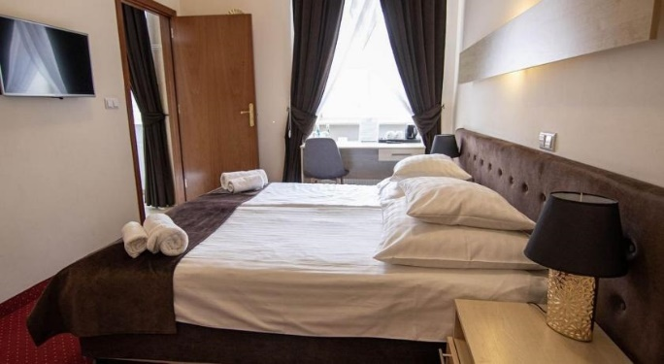 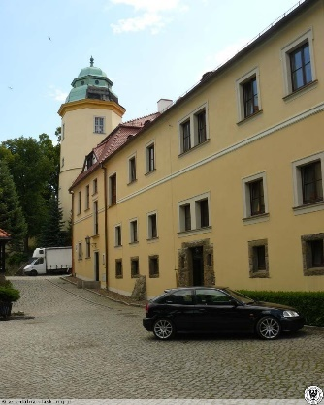

**Książęcy Hotel – Three Star Hotel**

* Single Room price: EUR 180.00 per room
* Number of rooms: 3
* Double/Twin Room price: EUR 280.00 per room
* Number of rooms: 23
* Triple Room price: EUR 330.00 per room
* Number of rooms: 3
* Board plan: breakfast and dinner
* Check-in from 13 September 2025
* Hotel website: <http://ksiazhotel.pl/>

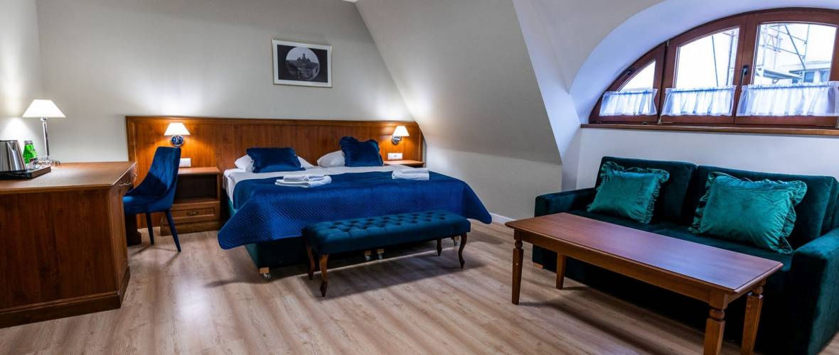 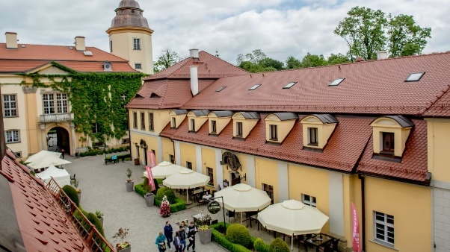

**Pod Oślą Bramą Hotel – Three Star Hotel**

* Single Room price: EUR 180.00 per room
* Number of rooms: 8
* Double/Twin Room price: EUR 270.00 per room
* Number of rooms: 8
* Board plan: breakfast and dinner
* Check-in from 13 September 2025

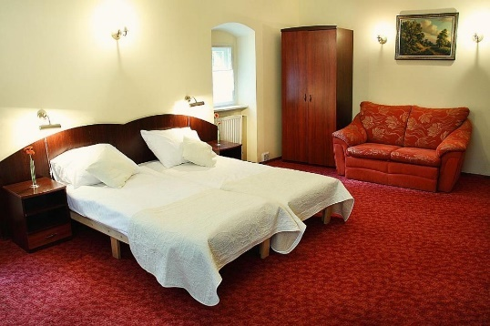 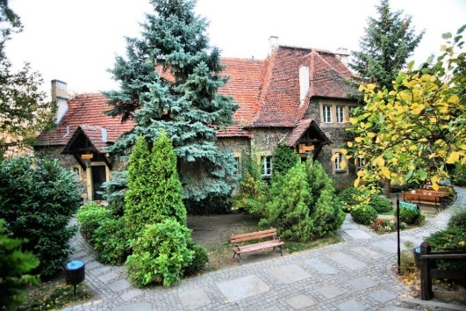

**Ibis Styles Wałbrzych Hotel – Three Star Hotel**

* Single Room price: EUR 180.00 per room
* Number of rooms: 63
* Double/Twin Room price: EUR 280.00 per room
* Number of rooms: 33
* Board plan: breakfast and dinner
* Check-in from 07 August 2025
* Hotel website: <https://all.accor.com/hotel/9123/index.pl.shtml>

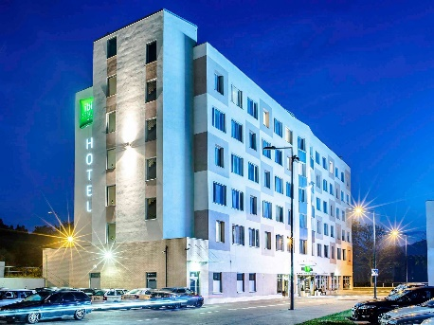 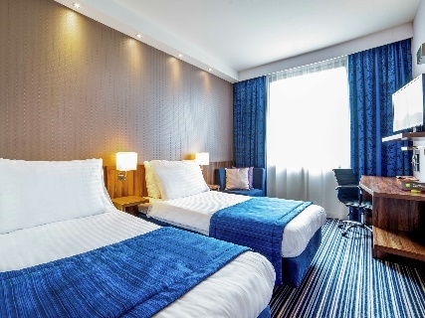

**Important Note:** Please refer to the accommodation webpages for detailed hotel information. Complete all necessary sections in WAREOS and make full payment for entries and accommodation by the specified deadlines. Bank transfers only, no credit cards will be accepted.

Hotels are allocated on a first come, first serve basis. Accommodation includes breakfast and dinner with water.

**LUNCH**

Lunch will be available the archery venue. Teams can order lunch through WAREOS system. Price is **20€** per lunch.

**TRANSPORTATION**

L.O.C. will provide transportation services with dedicated vehicles for Delegations and

International-National Technical Officials for all days of training and competition. This

service will start at the official opening of the training field until the closure and will

operate for opening/closing ceremonies and arrivals/departures too. The L.O.C. will

provide transportation service from September 13 until 21, including arrival and

departure transfer services from/to Wroclaw International Airport

Transport from Wroclaw International Airport is available at price **30€** per person one way

Transport from IBIS Hotel to competition venue will be provided by LOC at no additional cost. From other hotel **NO** transport will be provided as those are 10 minute walk to the venue.

**VISA**

All participants who need an entry visa to Poland, will be required to complete the **Visa Support sections** in WAREOS by no later than **09 May 2025**.

It is the applicants’ responsibility for supplying the necessary information, ensuring all details are up to date, correct and submitted by the deadlines specified.

In addition, all participants that require a visa are kindly requested to supply a copy of their latest/valid passport. Copies of each application can be uploaded on WAREOS. All passport copies and personal details entered/uploaded to WAREOS will be held securely and in the strictest of confidence and not shared with other parties.

**PAYMENT CONDITIONS:**

The entry fees should be paid in full before arrival.

To confirm hotels reservations, a minimum 50% deposit of the total amount is required to be bank transferred to the OC before **17 June 2025**. Reservations after this date will be considered only according to availability. The final outstanding balance shall be made via bank transfer before arrival. Accommodation cannot be guaranteed after this deadline. A balanced invoice will be provided via WAREOS.

**There are different bank accounts for entry fees and accommodation.**

**BANK INFORMATION for ACCOMMODATION, TRANSPORTATION**

A/C Name: OSL Strzelec

LOC Address: ul. Górnicza 9, 59-220 Legnica, Poland

Telephone number: +48 693 456 883

City and Country: Legnica, Poland

Bank: BNP Paribas Polska SA

Account Number: PL 28 2340 0009 0901 2460 0000 0010

Swift: PPABPLPK

Bank’s address: Najświętszej Marii Panny 4 Street, Legnica, Poland

Bank’s Phone: +48 22 134 00 00

**BANK INFORMATION for ENTRY FEES:**

A/C Name: Polski Związek Łuczniczy

LOC Address: Oleandrów 6 Street, 00-629 Warsaw, Poland

Telephone number: +48 22 622 02 45

City and Country: Warsaw, Poland

Bank: PKO BP SA

Account Number: PL 32 1020 4900 0000 8502 3764 6632

Swift: BPKOPLPW

Bank’s address: Chłodna 52 Street, 00-872 Warsaw, Poland

**NOTE**: ALL PAYMENTS SHALL BE MADE IN EUR BY BANK TRANSFER.

All bank charges will be paid by the participants. CREDIT CARDS are not accepted.

**CANCELLATIONS & CHANGES**

All cancellations and changes must be made through WAREOS:

* Cancellations received **before 26 August 2025** a full refund of the deposit payment will be made.
* Cancellations received **after 26 August 2025**, no refund will be given.
* Refunds will be processed after the event.
* Should flight arrival details change last minute, please contact the Organising Committee using the details indicated in the team managers’ booklet.
* If a participant’s arrival is later than the original scheduled arrival date, the

room will be charged from the date of the original booking in WAREOS.

* An email will automatically notify the Organising Committee and Member Association of any changes made in WAREOS.

**ADDITIONAL INFORMATION**

**Medical emergency contact and location**

Hospital Name: Specjalistyczny Szpital im. dra Alfreda Sokołowskiego address: Batorego 4 Street, Wałbrzych 58-300

phone number: +48 74 64 89 659

**Practice**

A training field will be available starting on **13 September 2025** at competition venue

**Weather**

September averages:

Avg. High Temp 17°C

Avg. Low Temp 8°C

Avg. Precipitation 43 mm

**Media Registration**

Media representatives can apply for registration by emailing osl.strzelec@interia.eu

**Internet**

Will be available in the official hotels for free (in hotel rooms and in the lobby). There will also be Wi-Fi available for access to results on venue.

**Water**

Bottled water will be available at the qualification and practice venues.

**LOC CONTACT**

Official website: field2025.pl

**L.O.C. Secretary General**

Name: **Mrs. Małgorzata Szałańska**

Address: Wroclawska 183a/4 Street, 59-220 Legnica, Poland

Language: Russian

Phone number: +48 693 456 883

E-mail: office@field2025.pl

**Transportation Manager:**

Name: **Mr. Michał Leszczyński**

Address: Wroclawska 183a/4 Street, 59-220 Legnica, Poland

Language: English

Phone number: +48 509 836 312

E-mail: transport@field2025.pl

**Marketing Director**

Name: **Mr. Maciej Karbowski**

Address: Wroclawska 183a/4 Street, 59-220 Legnica, Poland

Language: English

Phone number: +48 603 314 632

E-mail: office@field2025.pl

**Terms and Conditions**

**Introduction**

The Member Association acknowledges to have understood and accepted in their whole and without any restrictions the sale and purchase terms and conditions of this invitation package, and of the registration platform <https://extranet.worldarchery.sport/wareos/>.

Consequently, the Member Association who wishes to register to an event, and book some or all associated extras proposed by the local organizing committee acknowledges that they are fully aware present terms and conditions are accepted by entering information in WAREOS.

Any Member Association declares that it is entitled to enter a contractual relationship with the Local Organising Committee of the event, in accordance with these terms and conditions. 

The Local Organising Committee commits itself to communicate, within reason, to its potential clients the greatest information available on the following topics:

Description of the main characteristics of the proposed products and of their use.

Pricing  
Information on the methods of payment and reimbursement conditions.

**Article 1: Entirety**

The platform <https://extranet.worldarchery.sport/wareos/> is the propriety of, has been designed and created and is managed by World Archery Federation at Lausanne, Switzerland, and put at the disposal of the Local Organising Committee to facilitate registration to World Archery events.  
The present terms and conditions include any and all rights and obligations of the parties. No single, specific, or general term or condition that may appear on documentation sent, given, or handed over to a Member Association will alter, replace, or complete parts of or the entirety of these terms and conditions   
World Archery reserves the right to modify at any time and without any preliminary notification of any kind these terms and conditions.

**Article 2: Object**

The present terms and conditions define the rights and obligations of the parties in relation to the registration made through the platform <https://extranet.worldarchery.sport/wareos/> of services offered by the Local Organising Committee in the scope of the event it has been set for.

**Article 3: Contractual documents**

The present terms and conditions and the registration process make up the contractual documents between the parties.

**Article 4: Electronic signature:**

The Member Association’s entering registration information is the electronic signature which is binding between the parties in the same sense as a handwritten signature would be.

**Article 5: Registration Confirmation – Contract**

The contract is validated as soon as the Member Association has entered its preliminary registration by entering information in WAREOS. A modification of the registration is possible until the deadline for registration set in the document. Modifications may be subject to penalty fees.

**Article 6: Prices**

The official prices are listed in the “Policies and Procedures Athletes, officials and team management”, the invitation package prices will be based on the official price list, converted to the currency elected by the LOC for invoicing (CHF, EUR, or USD).

The official prices valid on the date that the registration confirmation is sent to the Member Association are binding between the parties.

**Article 7: Payment methods**

All payments shall be made by bank transfer to the organising committee respecting the stated deadlines, with all bank charges paid by the Member Association. For any open invoices that are not settled 21 days prior the beginning of the event, the Local Organising committee will be entitled to charge a 5% surcharge on all open amounts.

Any payments received cash by World Archery on behalf of the organising committee will incur a 10% additional service fee, to be paid to World Archery.

**Article 8: Payment deadlines and refunds**

After the preliminary’s entry deadline, the downpayment of 50% shall not be reimbursable. After the final deadlines of registration mentioned in this document, Member Association will not be entitled to any refund, and all remaining unpaid amounts shall be paid to the Local Organising Committee.

Failure to do so, will results in an immediate suspension of the Member Association, who will be set as not in good standing on the day of the official practice of the event, and so until the full amount is paid to the LOC.

**Article 9: Availability of services**

The availability of services is guaranteed on a first come, first serve basis, provided that the payment of such service has been paid to the local organising committee, partially or in full as mentioned in this document.

The local organising committee is not required to hold services for a Member Association that as not paid in full such service.

**Article 10: Force-majeure**

None of the two parties will have failed in their respective contractual obligations if their execution is delayed or prevented by a case of force-majeure. Cases considered to be a force majeure are extraordinary events or circumstances beyond the control of the parties, such as a war, strike, riot, crime, or an event described by the legal term "act of God" (e.g., flooding, earthquake, volcano eruption, etc). However, force majeure is not intended to excuse negligence or other malfeasance of a party, as where non-performance is caused by the usual and natural consequences of external forces, or where the intervening circumstances are specifically contemplated. The party experiencing a force majeure must notify in writing with 24 hours after becoming aware of the occurrence. The parties will then, within 7 business days examine, unless the force majeure prevents it, if and how the contractual obligations will be met.

**Article 11: Privacy statement**

All information exchanged by the Parties will be treated with the utmost confidentiality   
All information requested by World Archery and the Organising Committee from the Member Association are necessary to process the event registration and can therefore be communicated only to the contractual partners of World Archery and the Local Organising Committee.

World Archery and the Local Organising committee are authorized to send informative and promotional e-mails to the Member Association, using the WAREOS e-mail address and the contact person provided by the Member Association during the registration.

November 2024 by World Archery Federation, Maison du Sport International, Avenue de Rhodanie 54 - 1007 Lausanne (Switzerland)