

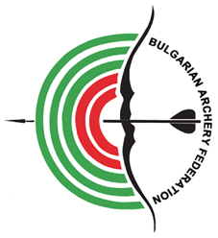

**EUROPEAN YOUTH CUP**

**INVITATION PACKAGE**

**First Leg**

**12-17 May 2025**

**INVITATION**

To all WORLD ARCHERY and WORLD ARCHERY EUROPE Member Associations

Dear President,

Dear Friends,

On behalf of the Local Organizing Committee and Bulgarian Archery Federation we are pleased to invite you to the 2025 European Youth Cup 1st Leg which will be held in Sofia, Bulgaria, 12-17 May 2025.

This event will be organized following the WA and WAE YOUTH CUP RULES for Under 21 Women, Under 21 Men, Under 18 Women and Under 18 Men classes, Recurve and Compound, and Under 21 Women, Under 21 Men Barebow divisions in the Outdoor Target Archery discipline.

THE PARTICIPATION IS OPEN TO ALL WORLD ARCHERY MEMBER ASSOCIATIONS.

Please find enclosed the necessary documents concerning the registration, organization and participation in this event. To register participation, please complete all the necessary sections in WAREOS within the deadlines listed below:

|  |  |  |  |
| --- | --- | --- | --- |
|  | **Registration opening deadline**  **Preliminary Entries** | **21 December 2024**  **1 March 2025** |  |
|  | **Final Entries** | **21 April 2025** |  |
|  |  |  |  |
|  | **Preliminary Hotel Reservation** | **1 March 2025** |  |
|  | **50% Hotel Reservation**  **Visa Support** | **1 March 2025**  **1 April 2025** |  |
|  |  |  |  |
|  | **Transportation** | **21 April 2025** |  |
|  | **Final Hotel Reservation & Payment** | **21 April 2025** |  |
|  | **Final Payment** | **21 April 2025** |  |
|  | **Full refund cancellation deadline** | **1 March 2025** |  |
|  | **Hotel Cancelation 100%** | **1 March 2025** |  |
| **! After this deadline, Member Association will be charged 30% of any cancelled hotel reservations.** | | | |
|  |  |  |  |
|  | **Hotel Cancelation 70%** | **21 April 2025** |  |
| **!! After this deadline, the LOC is allowed to retain all amounts due by the Member Association.** | | | |

We are looking forward to welcoming you and we are sure you will enjoy your stay in Sofia.

Website: <https://www.archeryeurope.org/> Yours sincerely **Atanas Temelkov**

E-mail: [**eyc@abv.bg**](mailto:eyc@abv.bg)President of the Organizing Committee &

Info: **+359 887 963009** President of Bulgarian Archery Federation

**PRELIMINARY PROGRAMME**

**Friday 09 May 2025** Arrival of Delegations

**Saturday 10 May 2025** Arrival of Delegations

Unofficial Practice

**Sunday 11 May 2025** Arrival of Delegations

Unofficial Practice

Team Registration

**Monday 12 May 2025** Opening

Official practice and Equipment inspection

Team Managers' Meeting

**Tuesday 13 May 2025** Qualification round Under 18

Qualification round Under 21

**Wednesday 14 May 2025** Mixed Teams

**Thursday 15 May 2025** Individual Eliminations – up to Semifinals

**Friday 16 May 2025** Team Eliminations and Finals  
 Team & Mixed Team Awarding

**Saturday 17 May 2025** Individual Finals

Award Ceremony/Closing Ceremony

Party

**Sunday 18 May 2025** Departure of Delegations

**Note:** This preliminary program is subject to changes according to the number of participants.

All changes and necessary information will be published and distributed in good time.

**Website**: <https://www.archeryeurope.org/>

**PRELIMINARY & FINAL REGISTRATION**

No entry forms will be available for registering for this event. The registration process should be done using the World Archery Online Registration System (WAREOS).

The number of athletes that may be entered by a Member Association is limited to four (4) in each recurve and compound category, and to one (1) in each barebow category.

All World Archery MA’s are eligible to compete in European Youth Cup competitions, but only the results of the athletes from WORLD ARCHERY EUROPE MA’s will be taken in consideration for the Youth Cup Circuit.

In order to use WAREOS, please login on <https://extranet.worldarchery.sport/> with your Username and Password assigned by World Archery. For any questions regarding the WAREOS, please contact the World Archery office [wareos@archery.sport](mailto:wareos@archery.sport)

|  |  |
| --- | --- |
| **Starting date of online registration with WAREOS is:** | **21 December 2024** |
| **End of Preliminary registration:** | **1 March 2025** |
| **End of Final registration:** | **21 April 2025** |

Please respect the deadlines stated!

Member Associations should only use WAREOS to make any changes/amendments to their entries and will be able to do so at any time. Any changes made in WAREOS email will instantly be automatically sent to the Organizing Committee and Member Association with the updated information.

However, any changes that are made after the deadlines specified or if entries differ by more than   
4 participants from the preliminary entries, the following penalty fees will automatically be applied:

|  |  |
| --- | --- |
| **Penalty fees to be paid to Organizing Committee:** | **Cost (EURO):** |
| Penalty fee for late entries (after the final deadline) | **€45** per entry |
| Penalty fee for not filling Preliminary entries | **€140** per entry |
| Penalty fee for differences between preliminary and final entries *: | **€140** per entry |

*If the difference between final and preliminary entries number is more than 4 athletes/officials

Any entries received less than 3 days before the team managers’ meeting will be refused if no preliminary entry and/or final entry are made prior.

As a final note, only Member Associations in good standing will be eligible to compete. This means that World Archery fee must have been paid prior the participation.

ACCOMMODATION & GENERAL INFORMATION

Important Note:

Non-official accommodation is not allowed. Any team or individual accommodated in non-official hotel will not be accredited and participation in the event will be refused.

The official hotels are 4* stars category hotels - HOTEL ZOO, PARK HOTEL VITOSHA and B1 CITY HOTEL in Sofia.

The room rate:

* are in **Euro (€)** per room, per night
* include full board accommodation, taxes and VAT
* including free internet in hotel lobby and rooms
* Check-in after 3:00 PM
* Check-out till 11:00 AM
* Additional purchases in the hotel bar, café and mini bar are at own expense. *

*All prices are including city tax.

|  |  |  |  |  |  |
| --- | --- | --- | --- | --- | --- |
| HOTEL | Category | Single room | | Twin room | |
| Price per room per night - full board | Number of rooms | Price per room per night - full board | Number of rooms |
| **HOTEL ZOO SOFIA** | **** | **€140** | **30** | **€220** | **50** |
| **PARK HOTEL VITOSHA** | **** | **€150** | **40** | **€240** | **50** |
| **B1 CITY HOTEL** | **** | **€150** | **30** | **€240** | **40** |

*Lunch during the competition days will be served in the restaurant of the Hotel.

**At HOTEL ZOO SOFIA we can arrange limited number of specific accommodation for more than two people in a room upon request

To confirm the reservation, a 50% deposit of the total amount is required to be bank transferred to the OC before **1 March 2025** Reservations after this date will be considered only according to availability, the room rate can change and we cannot guarantee rooms in the official hotel.

**Final** Hotel Reservations and remaining payment should be made before **21 April 2025**

**Note: Please ensure that you complete all the necessary forms by the specified dates and make full payment for the accommodation at the time of booking. See detailed payment instructions below.**

**HOTEL ZOO** ****

6 Simeonovsko shose blvd., 1700 Sofia, Bulgaria

2.8 km from Venue

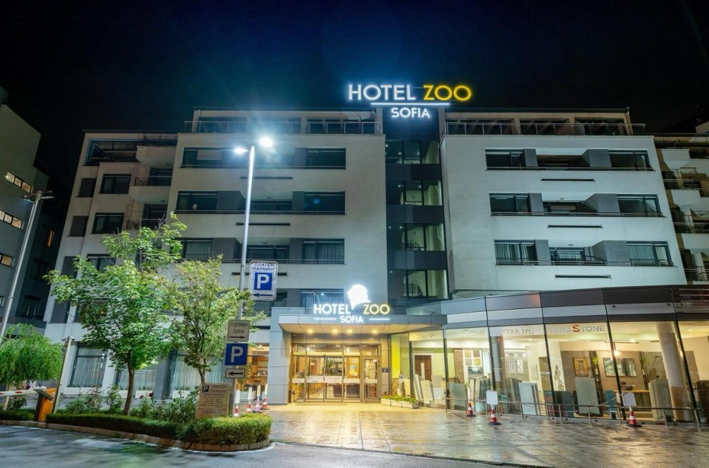

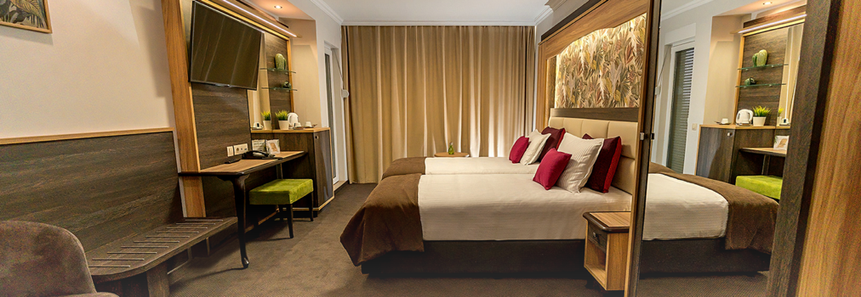

**PARK HOTEL VITOSHA** ****

1 Rosario Street, Sofia 1700, Bulgaria

1.4 km from Venue

Reservations should be made before **…………………….**

**B1 CITY HOTEL** ****

2 Boyan Damyanov, Sofia, Bulgaria

6 km from Venue

Reservations should be made before **1 March 2025**

VENUE

**NATIONAL SPORTS ACADEMY (NSA) “VASSIL LEVSKI”**

1 Akad. Stefan Mladenov, Sofia 1700, Bulgaria

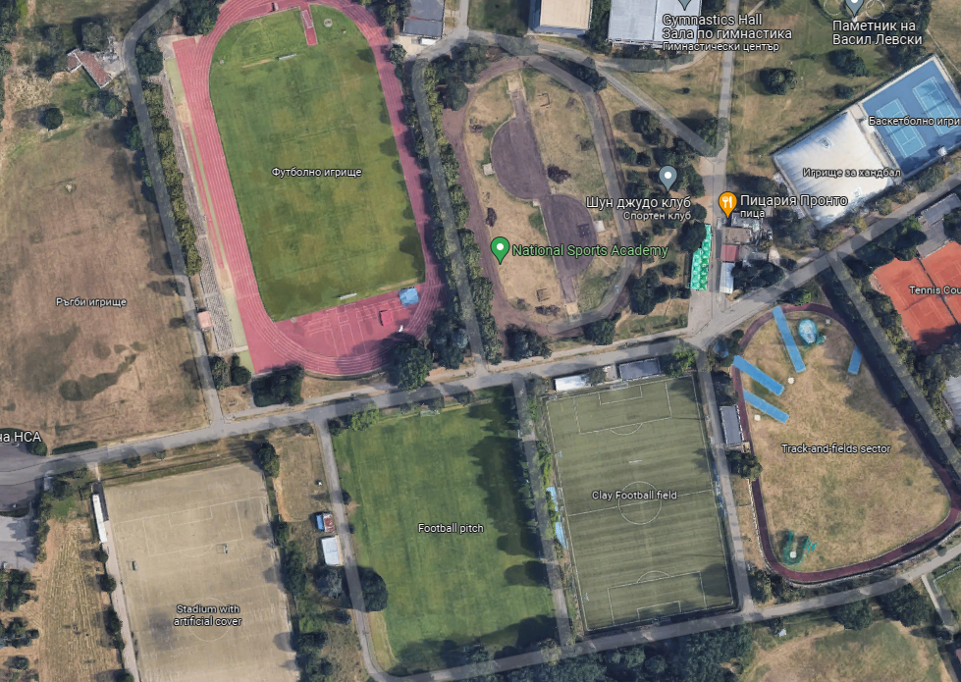

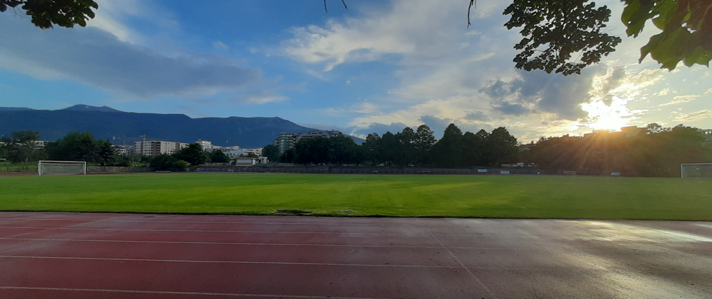

MAP

Important Note:  
Refer to the accommodation pages for detailed hotel information. Please complete all the necessary sections in WAREOS and make full payment for entries, transport, and accommodation by the specified deadlines.

ADDITIONAL INFORMATION

Entry fees

Individual: **€120** per athlete

Officials: **Free**

Teams: **Free**

Transportation fees from/to the airports

The OC will collect the teams from the Sofia Airport or Sofia Central Railway Station. You have to pay the transportation fee as follows:

SOFIA airport to Official Hotels – (one way): **€30** /person

SOFIA Central Bus/Railway Station to Official Hotels – (one way): **€30** /person

Official Hotels to SOFIA airport – (one way): **€30** /person

Official Hotels to SOFIA Central Bus/Railway Station – (one way): **€30** /person

The last date for the payment of the transportation fee is **21 April 2025**

Between airports and hotel, the organizer will use buses, small buses, vans and cars, what will depend of number of persons scheduled for transportation. Transportation from the airports will start two days before the official practice day and will end the day after the closing day.

A daily shuttle service will be available for the tournament days from the Official Hotels to the competition venue and back - free of charge.

Cancellations & Changes

Following conditions will apply:

* cancellation received before the preliminary entry: full refund of the paid deposit.
* cancellation received after the preliminary entry but before the final entry: 70% refund of the cancelled reservations for hotel deposit and full refund of the paid transportation and fees deposit.
* cancellation received after the final entry: no refunds.

All rates for payments after deadlines are subject to additional charges without prior notice.

All refunds, if any, will be processed after the event.

OC has to be informed about changes in the travel programme 72 hours prior arrival. If your arrival is later then your original schedule, the room charges are starting from the original date indicated by the Member Association.

Meals at the venue

Lunch will be served in the restaurant of the hotel.

Drinking water will be available at lunch and at dinner and on the competition field free of charge.

All other costs made in cafeteria at the archery venue or in the hotel /snacks, drinks, small meals/ are not included in the entry fee and must be paid on consumptions.

**Please inform us if you have special requirements for food and specify it.**

Accreditation and Team Managers Meeting

Accreditation will take place upon arrival of teams on Sunday, **11 May 2025**

Accreditation office will be open from **10:00** till **20:00**.

For all Ceremonies WA dress code is obligatory.

More details will be provided at the Team Manager’s Meeting.

Team Managers Meeting will be held on Monday, **12 May 2025**

Training and Competition Field

For European Youth Cup Training venues will be available starting from Sunday, **11 May 2025 14:00**

**Please inform us if you would like to arrive earlier and have extra training time in Sofia.**

VISAs

All participants who need an entry visa to Bulgaria, will be required to complete the Visa Support Form in WAREOS by **no later than 1 April 2025**.

It is the applicants’ responsibility to supply the necessary information, ensuring all details are up to date, correct and submitted by the deadlines specified.

In addition, all participants that require a VISA are kindly requested to supply a copy of their latest/valid passport. Copies of each applicant can be uploaded on WAREOS. All passport copies and personal details entered/uploaded to WAREOS will be held securely and in the strictest of confidence and not shared with other parties.

Please note that the Organizing Committee can provide invitation for the period of the European Youth Cup in Sofia only.

As long as the Organizing Committee gets no different information, the Invitation Letter will be sent by email. If an express service should be desired, this service will be charged to the MA and must be paid to the Organizing Committee upon arrival.

Please note: the deadline for Visa Invitation Letter Form is **1 April 2025**.

Party

On the final day - Saturday, 17 May 2025, after dinner in hotels, Party will be organized at Park Hotel Vitosha hall Vitosha, next to the main building 19:30-22:00.

One non-alcoholic drink and small snacks will be provided at the Party.

Registration for the Party can be done via WAREOS or at accreditation desk.

Internet

Will be available at the official hotels for free.

There will also be Wi-Fi available for access to results at the venue.

Website

The official website of the competition is <https://www.archeryeurope.org/>

PAYMENT CONDITIONS

All fees should be paid in full before arrival!

Payment of accommodation and local transportation: a minimum deposit of 50% of the total amount owed should be made when booking by **1 March 2025**.

The final outstanding balance shall be transferred before **21 April 2025**.

Accommodation cannot be guaranteed after this deadline. A balance invoice will be provided via WAREOS.

NOTE:

Please indicate in the reference/notes section the team or reservation name that corresponds to the payment.

All payment shall be made in EURO only by BANK TRANSFER LATEST **21 April 2025**!

Bank transfer fees are responsible on the sender.

Credit cards and Travel checks will not be accepted.

PLEASE SEND THE COPY OF THE BANK TRANSFER TO THE ORGANIZER by email to: [**eyc@abv.bg**](mailto:eyc@abv.bg)

BANK INFORMATION for ACCOMMODATION, TRANSPORTATION and ENTRY FEES:

BANK: FIRST INVESTMENT BANK

SWIFT CODE: FINVBGSF

IBAN: BG13FINV91501203792590

ADDRESS: 37, Dragan Tsankov Blvd., 1797 Sofia, Bulgaria

NOTE: ALL PAYMENTS SHALL BE MADE IN EURO

**LOC CONTACT**

Website: <https://www.archeryeurope.org/>

https://www.facebook.com/ArcheryEuropeanYouthCup

E-mail: [**eyc@abv.bg**](mailto:eyc@abv.bg)

Name: Atanas Temelkov

Mobile phone: + 359 88 796 3009

Name: Alexandar Pagkou

Mobile phone: + 359 88 464 0216

Looking forward to welcoming You in SOFIA, Bulgaria!