**Dear President,**

On behalf of the Organizing Committee, I am pleased to invite you to the 20th European Archery Indoor Championships that will be held in Samsun - TÜRKIYE, on 17 - 23 February 2025.

This Competition will be organized following the WA and WAE competition rules in divisions Recurve, Compound and Bare Bow with both age categories of Senior Men and Women and Under 21 Men and Women.

Hereby please find enclosed all the necessary documents concerning the registration, organization and participation in this event.

Please complete all the necessary sections in WAREOS within the deadlines listed below, to register participation;

* **Preliminary Entries 15 December 2024**
* **Final Entries 28 January 2025**
* **Hotel Reservation 15 December 2024**
* **Entry Fee & Transportation 15 December 2024**
* **Final Hotel Reservation 28 January 2023**
* **Final Entry & Transportation 28 January 2025**

We hope you and your team will enjoy your stay in Samsun, where you will experience Turkish Hospitality at its best.

Yours sincerely,

Abdullah TOPALOĞLU

Chairman of the Organizing Committee

**PRELIMINARY PROGRAM**

16th of February 2025, SundayArrival of Delegations & Accreditation

Unofficial Practice

17th of February 2025, MondayArrival of Delegations & Accreditation

Unofficial Practice

18th of February 2025, Tuesday Official Practice & Equipment Inspection

Team Manager’s Meeting

19th of February 2025, Wednesday Qualification Rounds

20h of February 2025, Thursday Senior Individual Eliminations, ¼ and ½ Finals

Junior Individual Eliminations, ¼ and ½ Finals

Barebow Eliminations

21st of February 2025, Friday Senior Teams Eliminations

Junior Teams Eliminations

Barebow Teams Eliminations

22nd of February 2025, Saturday Junior Teams Bronze & Gold Finals

Junior Teams Award Ceremony

Junior Individuals Bronze & Gold Finals

Junior Individuals Award Ceremony

23rd of February 2025, Sunday Senior Teams Bronze & Gold Finals

Senior Teams Award Ceremony

Senior Individuals Bronze & Gold Finals

Senior Individuals Award Ceremony

24th of February 2025, Monday Departure of Teams

**Note**

This preliminary programme could change according to the number of participants and TV requirements. All changes to the programme will be published and informed to all participants in good time.

**PRELIMINARY & FINAL REGISTRATION**

All entries, accommodation reservations, transport needs, flight arrival/departure information and visa invitation letter requests are to be completed using the World Archery Online Registration System WAREOS <https://extranet.worldarchery.sport>. This system handles the entire registration process for this event. No entry forms, hotel reservations or transportation forms will be accepted; all information must be entered into WAREOS.

Member associations can login to WAREOS at <https://extranet.worldarchery.sport> with the username and password assigned by World Archery. After entering WAREOS, selecting the event from the list will allow a member association to register their athletes. Select/press the “Entries” button to see the list of categories in the event. Select/press the “category” to enter the athlete and official numbers/details participating for that event. A WAREOS User Manual can be downloaded in PDF format (English) upon login.

Contact [wareos@archery.sport](mailto:wareos@archery.sport) with any questions regarding **technical problems on WAREOS**. For any question regarding the organisation of the event (transport, accommodation, meals, invoices, visa etc.) please contact **directly the LOC**.

A maximum number of 3 athletes per country can be registered into each category of the event. Preliminary entries should be completed using WAREOS.

Member Associations can only use WAREOS to make any changes or amendments to entries and will be able to do so at any time. An email will automatically notify the Organising Committee and Member Association of any changes made in WAREOS.

**A maximum number of three (3) athletes per country** can be registered into each category and divisions of the event.

* Starting date of on-line registration with WAREOS : 21st of November 2024
* End of Preliminary Registration using WAREOS : 15th of December 2024
* End of Final Registration using WAREOS : 28th of January 2024

Please respect the stated deadlines.

Member Associations should only use WAREOS to make any changes/amendments to their entries and will be able to do so at any time. Any changes made in WAREOS an email will be automatically sent to the Organizing Committee and Member Association with the updated information.

However, any changes that are made after the deadlines specified or if entries differ by more than 4 athletes from the preliminary entries, the following penalty fees will automatically be applied:

|  |  |
| --- | --- |
| **Penalty fees to be paid to Organising Committee:** | **Cost (EURO):** |
| Entries made after the preliminary and/or final entry deadline date. | **50** per entry |
| If final entries differ from the preliminary entries by more than 6 athletes/officials. | **150** per entry |
| Failure to have made preliminary entries before the deadline date but then have submitted final entries. | **150** per entry |

Any entries received less than 3 days before the team managers meeting will be refused if no preliminary entry and/or final entry are made prior.

As a final note, only Member Associations in good standing will be eligible to compete. This means that World Archery fee must have been paid prior the participation.

**ACCOMMODATION AND TRANSPORTATION**

Official Hotels will be the SHERATON GRAND SAMSUN HOTEL and THE NORTH POINT HOTEL. Hotel rates included “full board” (breakfast, lunch and dinner including beverages). In addition, tea, coffee and 0,5-liter water will be available from 10:00 to 22:00 hrs. at the hotels.

Room rates specified per room per night, which includes service charge and VAT.

Transportation Samsun Carsamba Airport is 90 € (Round Trip) per person for all participants. A daily shuttle service is free of charge (only for persons accommodated at official hotels). Shuttle services will be available from/to official hotel – competition venue.

Hotel and Transportation reservation should be made before 15 December 2024. Booking will only be valid once a 50% deposit has been received by the LOC before 15 December 2024. Full payments are to be made before 28 January 2025.

Reservation after this date shall be subject to availability.

**HOTELS**

Room rates for the hotels are per room per night and included Breakfast, Lunch and Dinner. There will be free internet access at the official hotels in at the lobby and rooms.

SHERATON HOTEL*****

Sheraton Hotel located 800m, 2 minutes (driving), 10 minutes walking distance to competition venue.

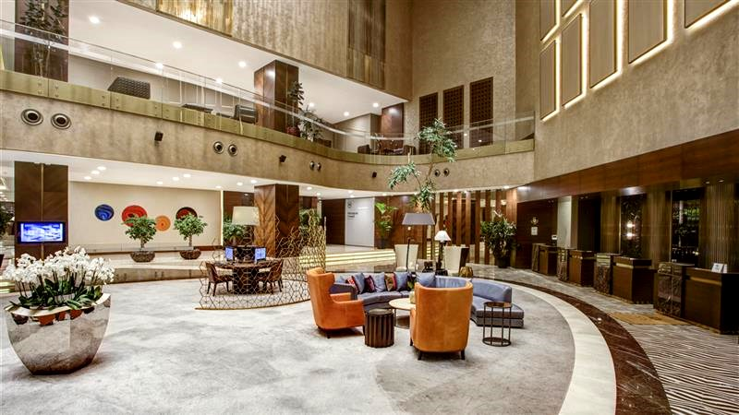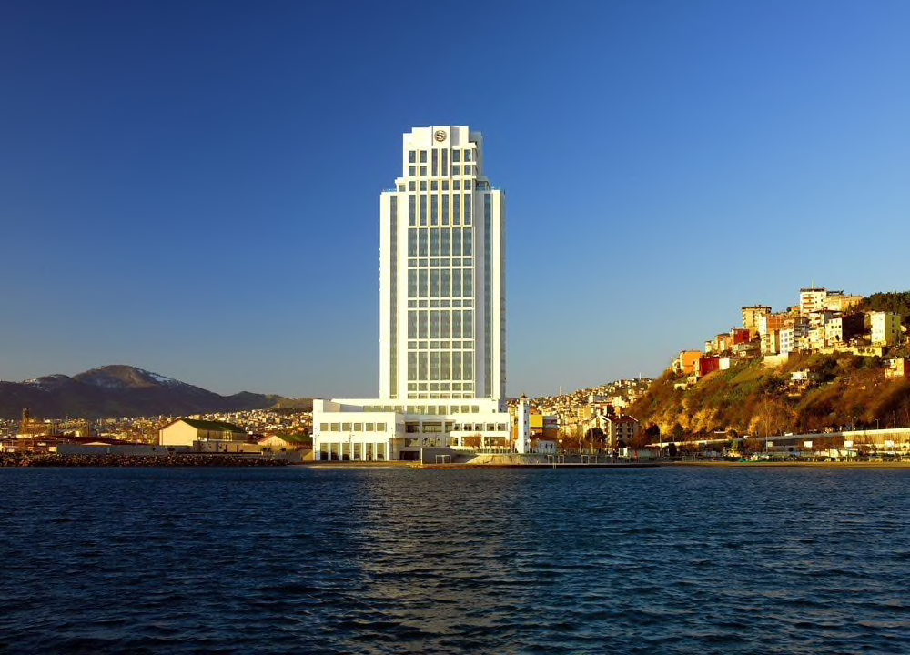

|  |  |
| --- | --- |
| **RATES PER ROOM PER NIGHT** | |
| Single Room | 270,00 € |
| Twin/Double Room | 360,00 € |

THE NORTH POINT HOTEL****

The North Point Hotel located on 10 min driving distance from venue.

**iç mekan, duvar, iç mekan tasarımı, oda içeren bir resim

Açıklama otomatik olarak oluşturuldu**

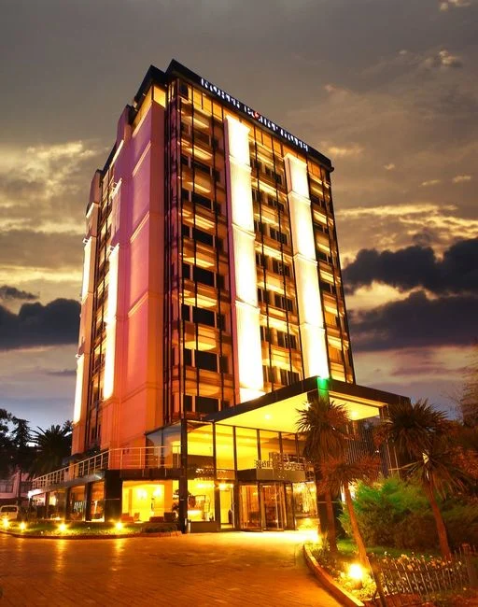

|  |  |
| --- | --- |
| **RATES PER ROOM PER NIGHT** | |
| Single Room | 225,00 € |
| Twin/Double Room | 300,00 € |

Non-official accommodation is not allowed. Any team or individual accommodated in non-official hotel will not be accredited and participation in the event will be refused.

**ENTRY FEES**

* Individual Entry Fee : 250,00 € per Archer
* Team Entry Fee : 150,00 € per Team
* Officials Entry Fee : 125,00 € per Official

**CANCELLATIONS & CHANGES**

Cancellation must be made by email to [samsun2025@okculuk.org.tr](mailto:samsun2025@okculuk.org.tr) and must be received before 27 January 2025 for a complete refund of deposit paid. Refunds will be processed after the event.

Any entries received after this date will not be eligible for refund. All rates for payment after deadlines are subject to additional changes without prior notice.

**PAYMENT INSTRUCTION**

All payments are to be made in Euros by bank transfer to;

**Payments for Accommodation Fee**

|  |  |
| --- | --- |
| BANK ACCOUNT: | ANTALYA OKCULUK IHTISAS SPOR KULÜBÜ |
| BANK: | YAPI KREDI BANKASI |
| ACCOUNT NO: | 25086669 |
| SWIFT CODE: | YAPITRIS |
| IBAN: | **TR 03 0006 7010 0000 0025 0866 69** |

#### Payments for Transportation and Entry Fee

|  |  |
| --- | --- |
| BANK ACCOUNT: | TURKIYE OKCULUK FEDERASYONU |
| BANK: | TEB BANKASI |
| ACCOUNT NO: | 681169866 |
| SWIFT CODE: | TEBUTRIS930 |
| IBAN: | **TR 65 0003 2000 0000 0068 1698 66** |

#### We regret that credit cards and travelers’ cheques will not be accepted.

#### Bank transfer fee is the responsibility of the sender.

#### Entry and accommodation fees must be paid in full before 27 January 2025.

#### VISA SUPPORT

#### All participants who need an entry visa to Turkey, will be required to complete the Visa Support Form in WAREOS by no later than 15 December 2024.

#### It is the applicants’ responsibility for supplying necessary information, ensuring all details are up to date, correct and submitted by the deadlines specified.

#### In addition, all participants that require a visa are kindly requested to supply a copy of their latest/valid passport. Copies of each applicate can be uploaded on WAREOS. All passport copies and personal details entered/uploaded to WAREOS will be held securely and in the strictest of confidence and shared with other parties.

#### If the applicants can obtain e-visa through [www.evisa.gov.tr](http://www.evisa.gov.tr) address, they won’t be able to receive Visa Support Letter through Turkish Foreign Ministry. They must complete their application and on online system. Please check your status through via [www.mfa.gov.tr](http://www.mfa.gov.tr) address.

#### Please note that the Organizing Committee can provide invitation only for the period of the 2025 European Archery Indoor Championship.

#### LOC CONTACT :

#### Name : Sirer AYDIN

#### E-mail : [samsun2025@okculuk.org.tr](mailto:samsun2025@okculuk.org.tr)

#### Phone Number : 00 90 533 515 25 33

#### Language : English

**ARCHERY VENUE**

The Qualification, Eliminations and Finals will be held at the Samsun Ilkadım Okculuk Tesisleri, Atatürk Bulvarı, Baruthane Mahallesi, 55100 Ilkadim, Samsun - TURKEY

**TRAINING**

A training field will be available starting from 16 February 2025. The training field will be located at the competition venue.

**WATER ON THE VENUE**

Bottled water will be provided on venue during the competition for accredited persons.

**WHETHER IN SAMSUN**

**February (Average):**

Average Temperature : 07O C

Low Temperature : 04O C

High Temperature : 10,6O C

Sunshine Hours : 3,2 Hrs.

Rainfall Days : 13,5 days

MEDIA REGISTRATION

Media representatives can apply for registration on the LOC website: [www.tof.gov.tr](http://www.tof.gov.tr) or by emailing media@tof.gov.tr (LOC media contact).

INTERNET

Will be available in the official hotels for free (in hotel rooms and in the lobby). There will also be Wi-Fi available for access to results and internet on venue.